Assignment Sakila

***MySQL***

**1. Rentals by Customer Geography**

1.1. Contribution of Countries & Cities (in hierarchy) by rental amount - Treemap (or Heatmap) & sql query

Answer: select country,city, sum(amount) as total_amount

from customer_list

inner join payment on customer_list.ID=payment.customer_id

group by city

order by country

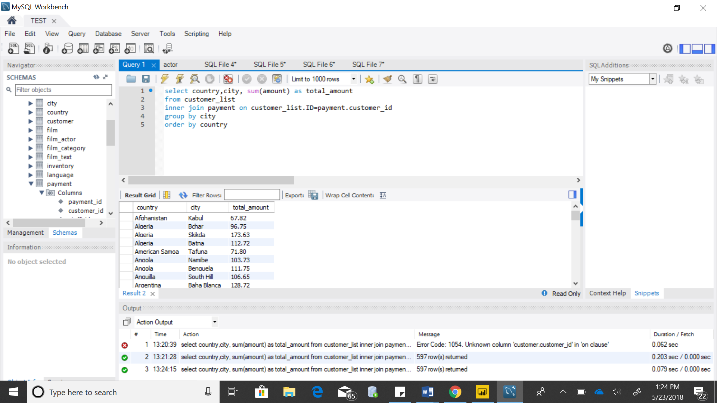

1.2. Rental amounts by countries for PG & PG-13 rated films - bar chart & sql query

select f.rating, sum(p.amount) as Rental_Amount

from film f

join inventory i

on f.film_id = i.film_id

join rental r

on i.inventory_id = r.inventory_id

join payment p

on r.rental_id = p.rental_id

group by f.rating

having f.rating = 'PG-13' or f.rating = 'PG'

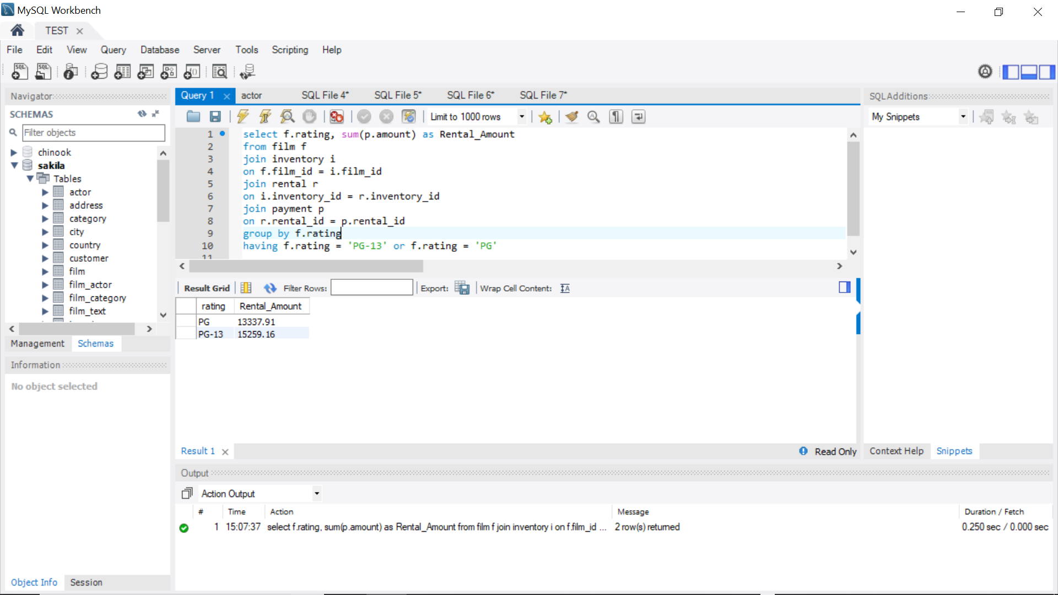

1.3. Top 20 cities by number of customers who rented - bar chart & sql query

Answer: 1.3. Top 20 cities by number of customers who rented - bar chart & sql query

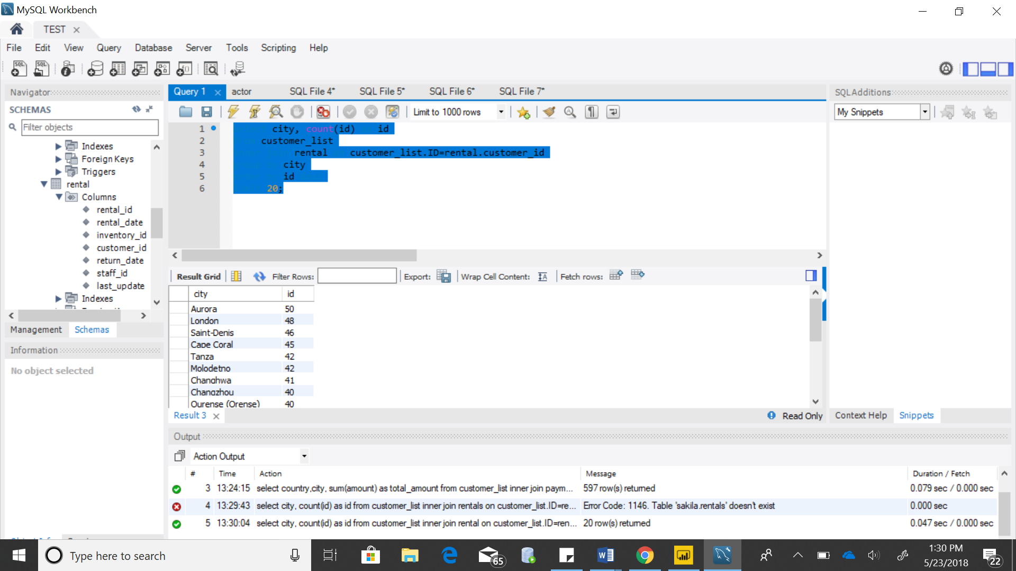

1.4. Top 20 cities by number of films rented - bar chart & sql query

Answer:select city, count(film_id) as fid

from rental

inner join inventory on rental.inventory_id= inventory.inventory_id

inner join customer_list on rental.customer_id= customer_list.ID

group by city

order by fid desc

limit 20;

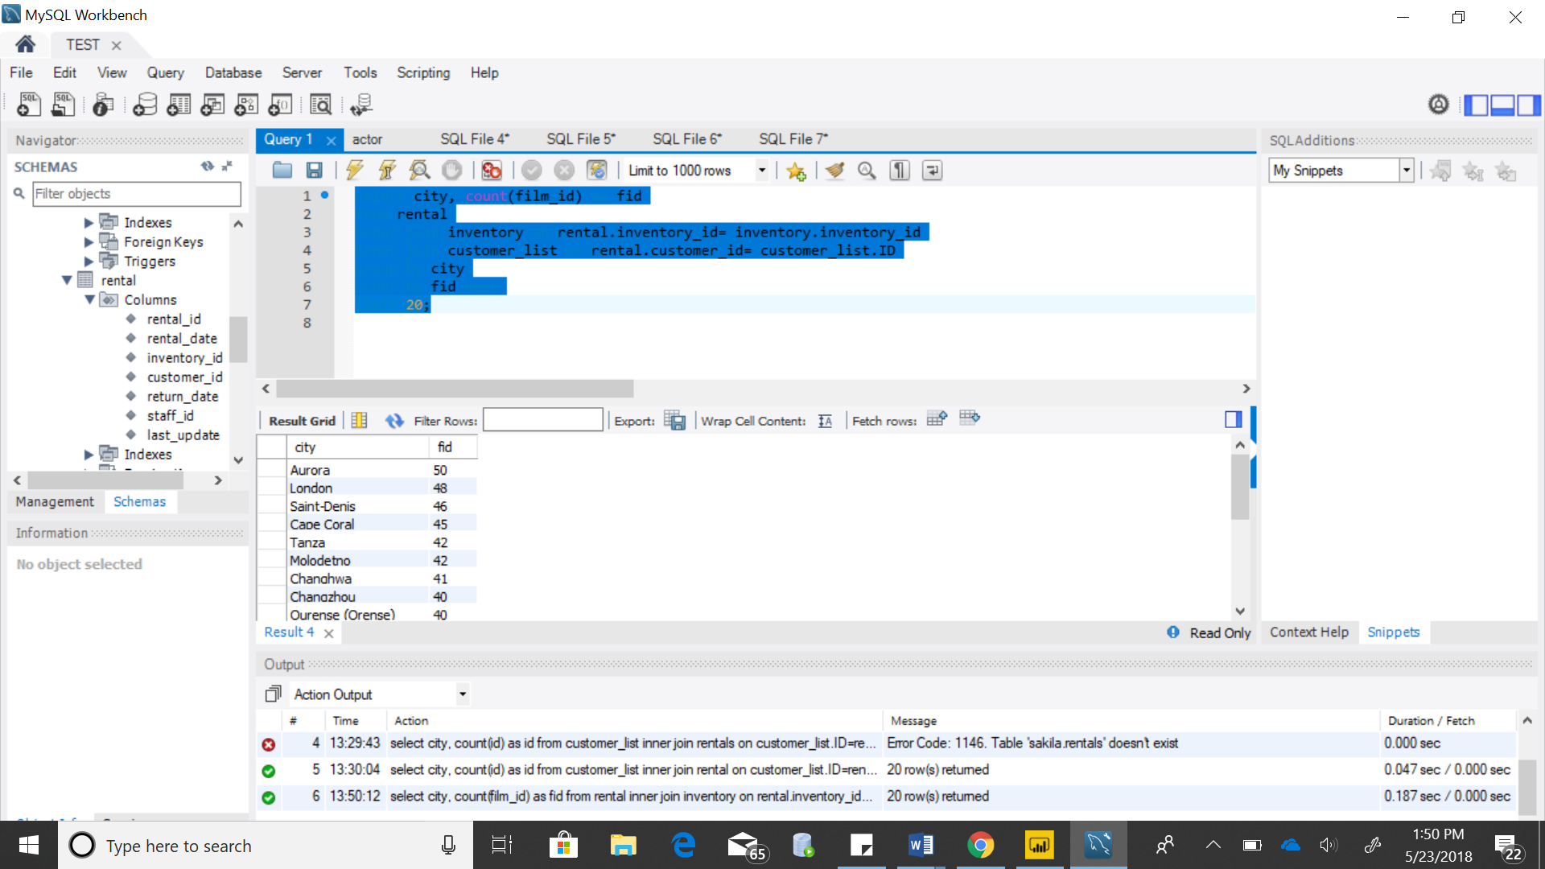

1.5. Rank cities by average rental cost - bar chart & sql query

Answer:select city, avg(amount) as Amount

from payment

inner join customer_list on payment.customer_id= customer_list.ID

group by city

order by amount desc

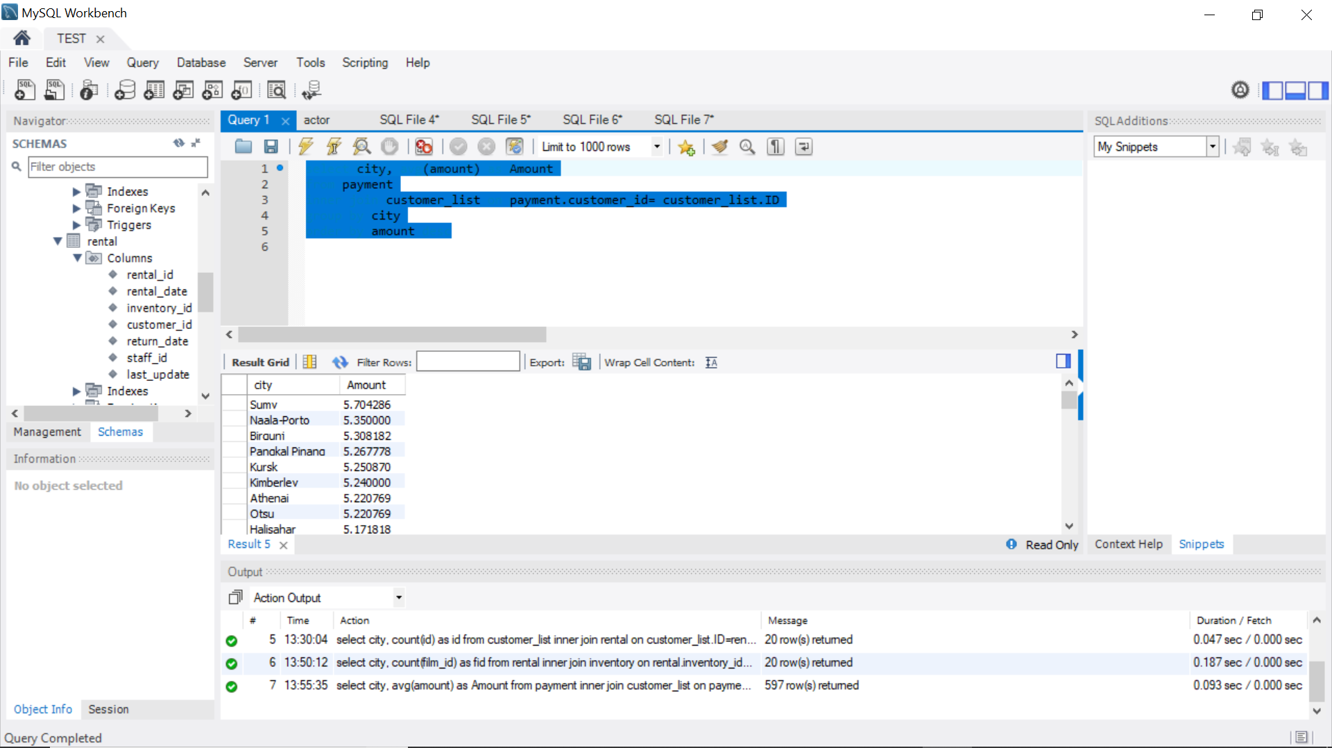

**2. Rentals by Film Category**

2.1. Film categories by rental amount (ranked) & rental quantity – tabular & sql query

Answer:

select Name, sum(rental_rate) as rentalamount, count(name) as quantity

from film_category

inner join film on film.film_id= film_category.film_id

inner join category on category.category_id= film_category.category_id

group by name;

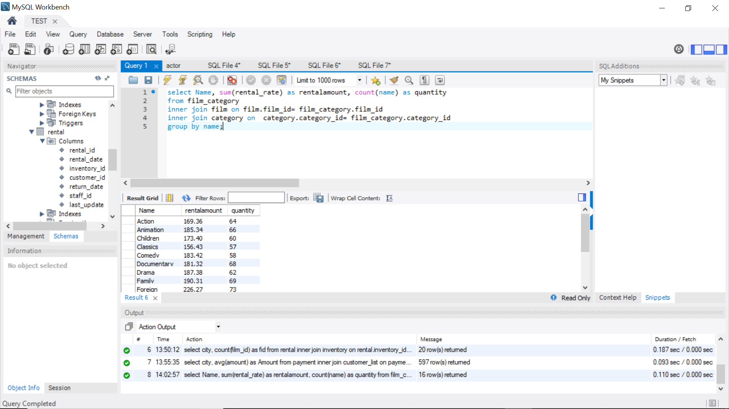

2.2. Film categories by rental amount (ranked) – bar chart & sql query

Answer: select name, sum(rental_rate) as rentalamount

from film_category

inner join film on film.film_id= film_category.film_id

inner join category on category.category_id= film_category.category_id

group by name;

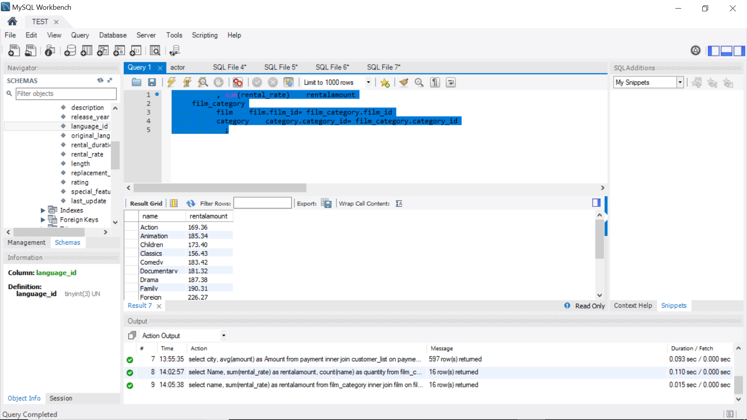

2.3. Film categories by average rental amount (ranked) & – tabular & sql query

Answer: select name, avg(rental_rate) as amount

from film_category

inner join film on film.film_id= film_category.film_id

inner join category on category.category_id= film_category.category_id

group by name

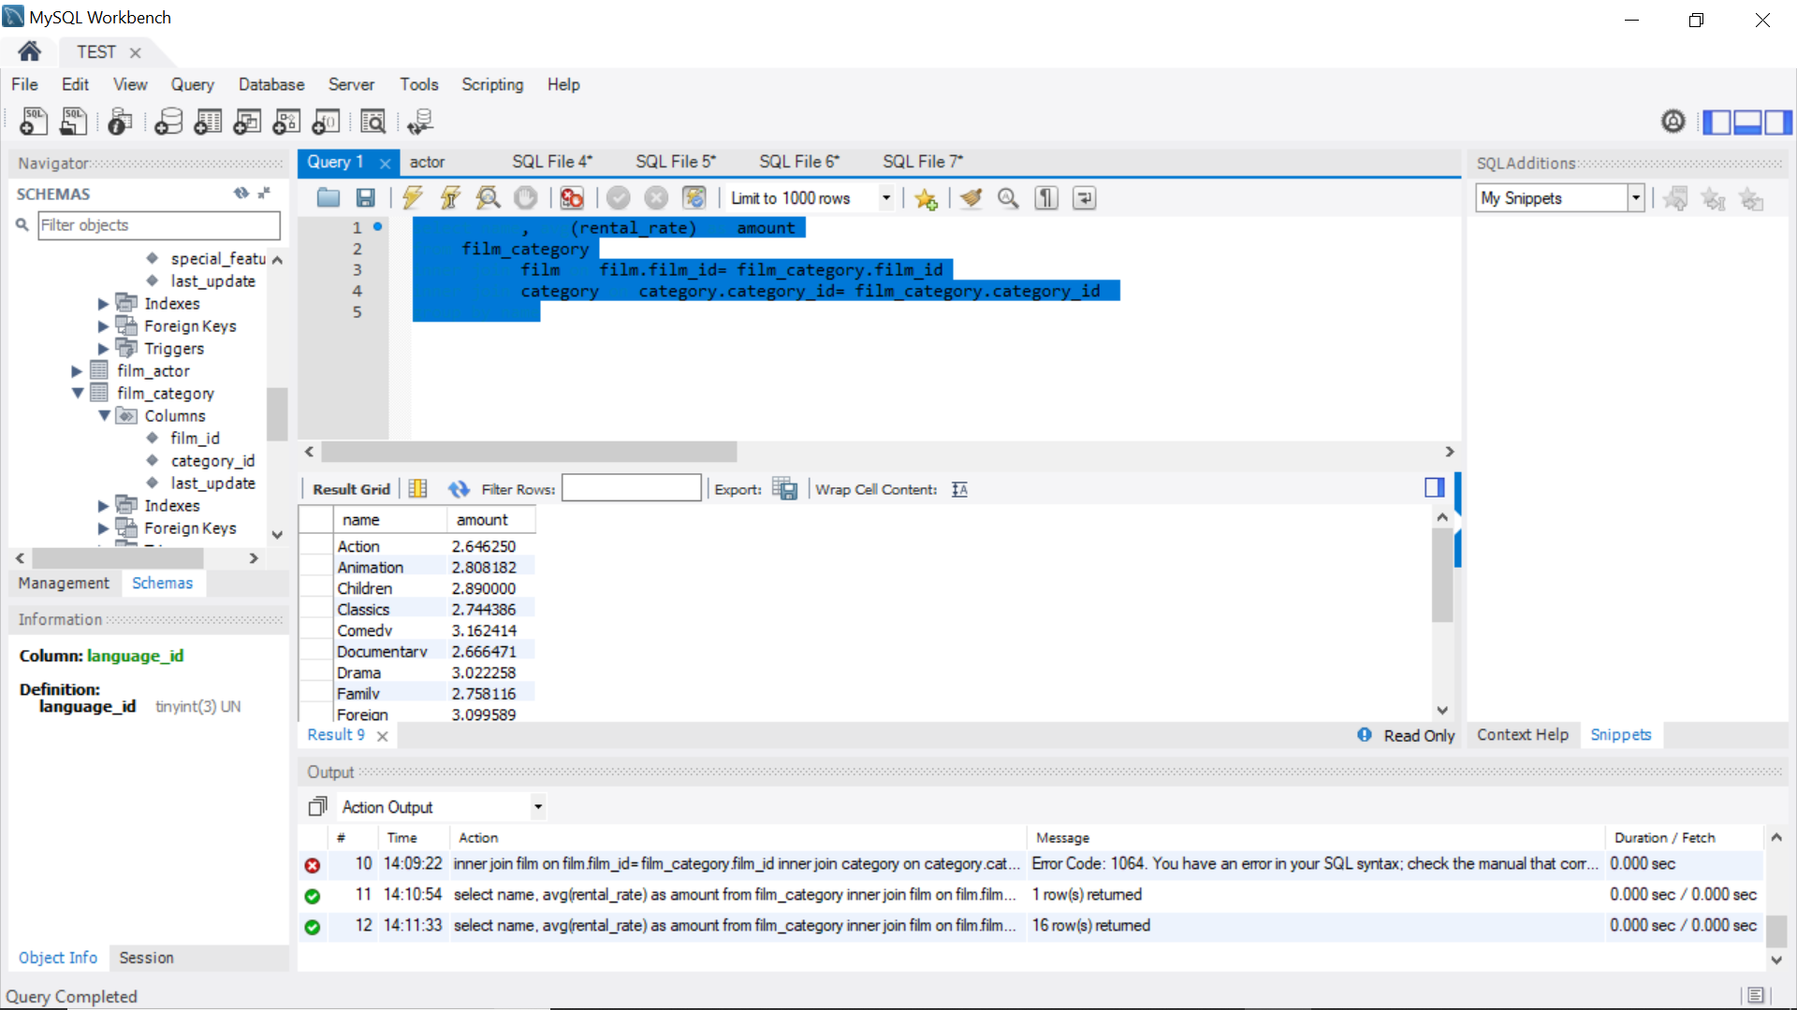

2.4. Contribution of Film Categories by number of customers - Treemap (or Heatmap) & sql query

Answer:

select count(rental.customer_id) as numberofcustomers, category.name as category

from film

inner join film_category on film.film_id = film_category.film_id

inner join inventory on film.film_id= inventory.film_id

inner join rental on inventory.inventory_id= rental.inventory_id

inner join category on film_category.category_id= category.category_id

group by name;

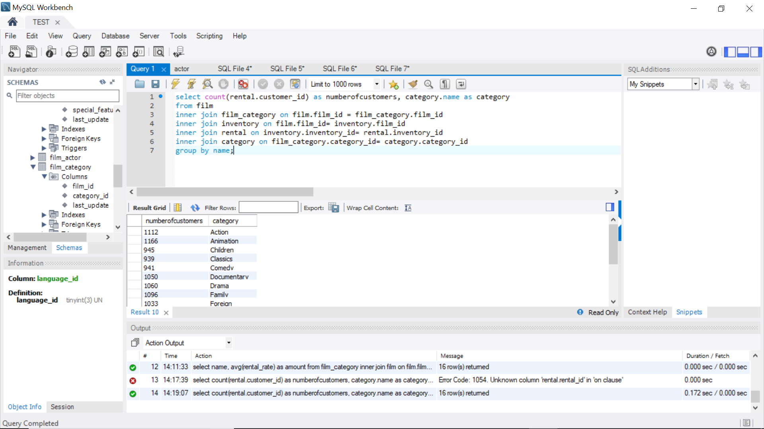

2.5. Contribution of Film Categories by rental amount - Treemap (or Heatmap) & sql query

Answer: select sum(rental_rate) as rental_amount, Name

from film_category

inner join film on film_category.film_id= film.film_id

inner join category on film_category.category_id= category.category_id

group by name;

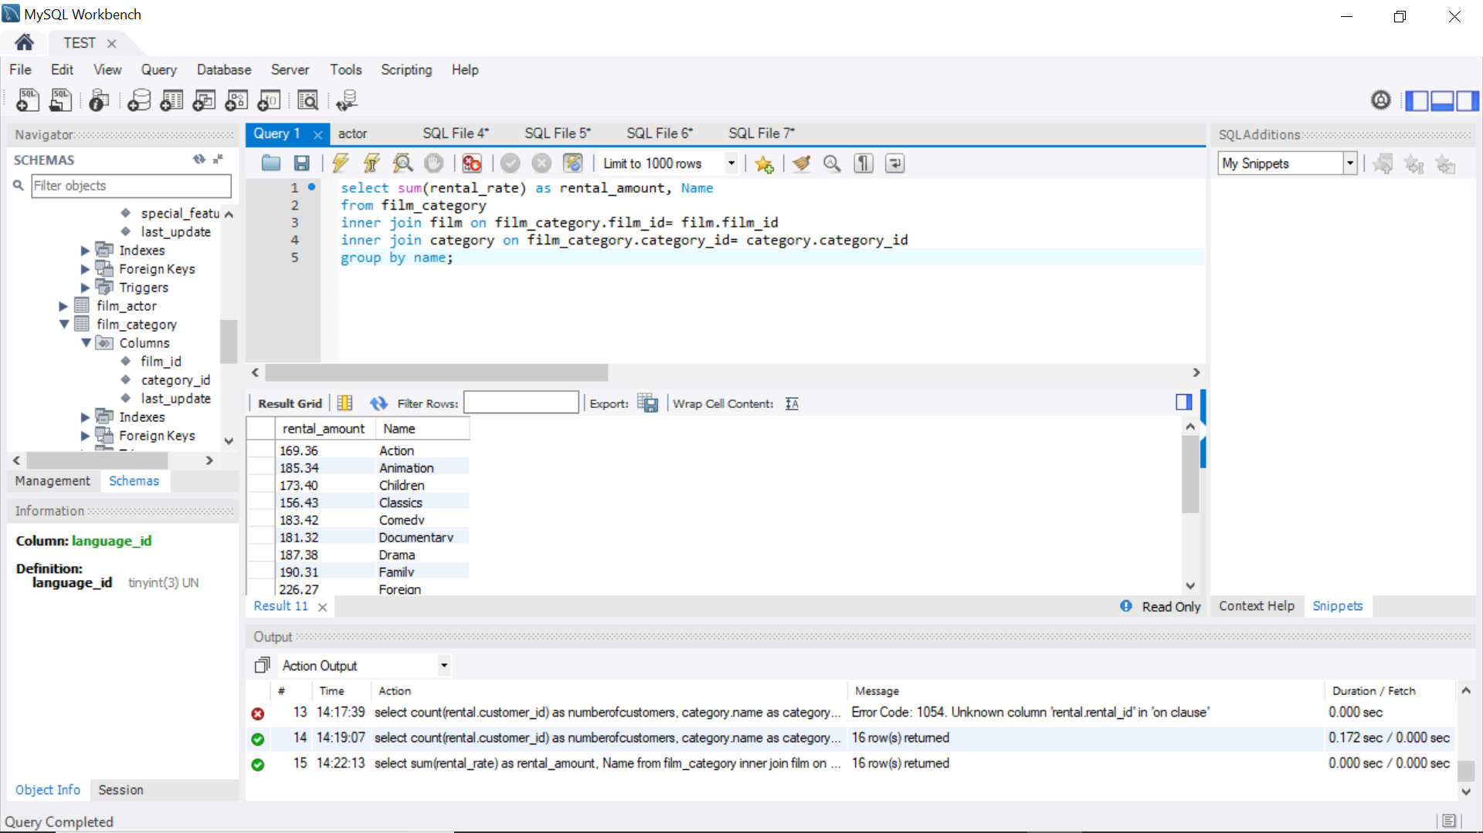

**3. Rentals by Film**

3.1. List Films with rental amount, rental quantity, rating, rental rate, replacement cost and category name – tabular & sql query

Answer:

select title,name,count(name) as quantity, rental_rate, replacement_cost, rating

from film_category

inner join film on film.film_id= film_category.film_id

inner join category on category.category_id=film_category.category_id

group by name;

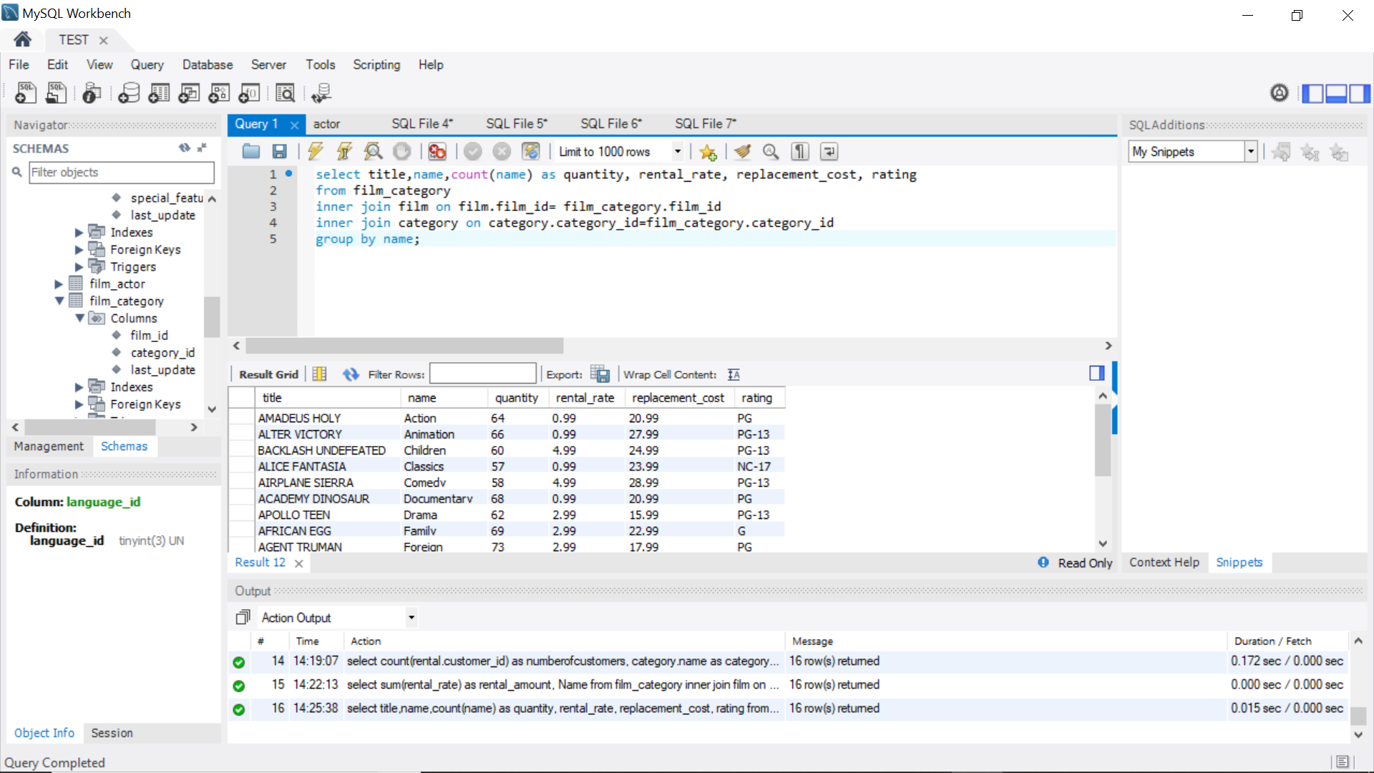

3.2. List top 10 Films by rental amount (ranked) – bar chart & sql query

Answer: select title, rental_duration, rental_rate as amnt

from film

order by amnt desc

limit 10;

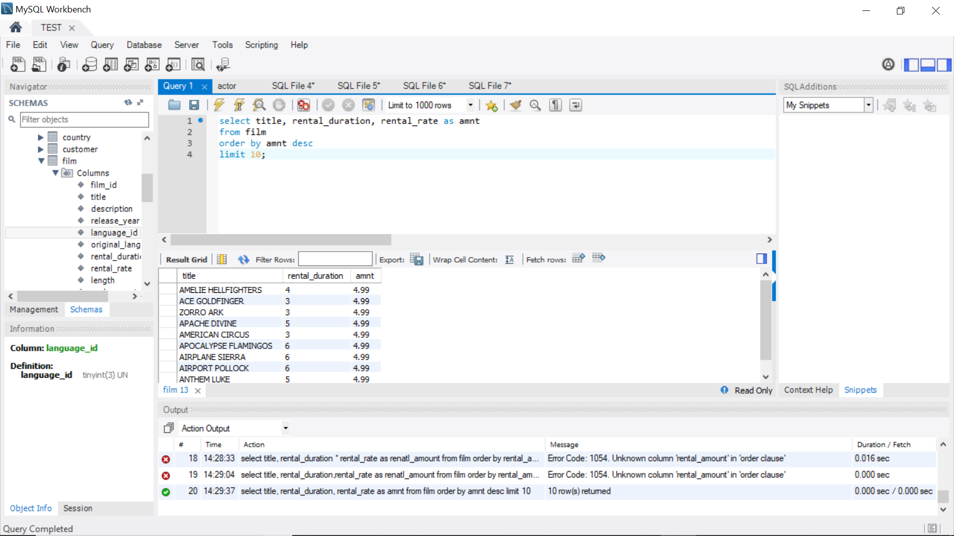

3.3. List top 20 Films by number of customers (ranked) – bar chart & sql query

select count(customer_id) as NoCustomers, film.title as title

from inventory

inner join rental on rental.inventory_id= inventory.inventory_id

inner join film on film.film_id= inventory.film_id

group by film.title

order by NoCustomers desc

limit 20;

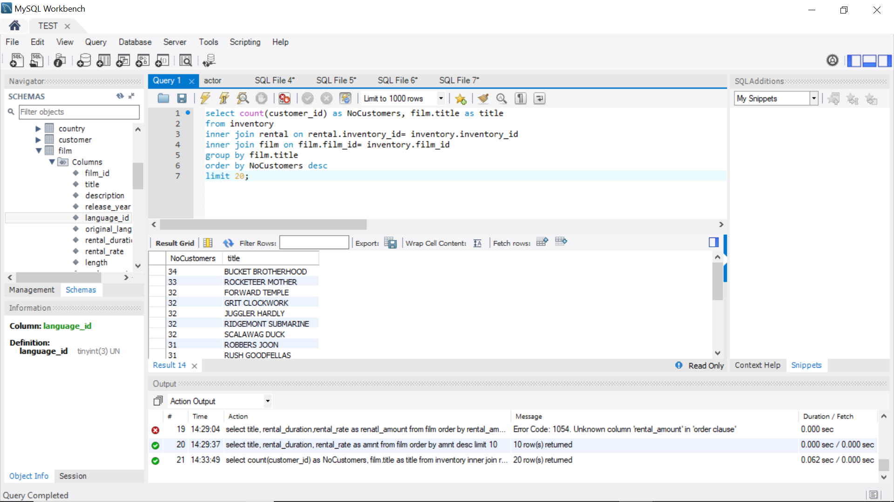

3.4. List Films with the word “punk” in title with rental amount and number of customers – tabular & sql query

select title,rental_duration, rental_rate as rentalamount, count(customer_id) as id

from inventory

inner join rental on rental.inventory_id= inventory.inventory_id

inner join film on film.film_id= inventory.film_id

where title like '%PUNK%'

group by title

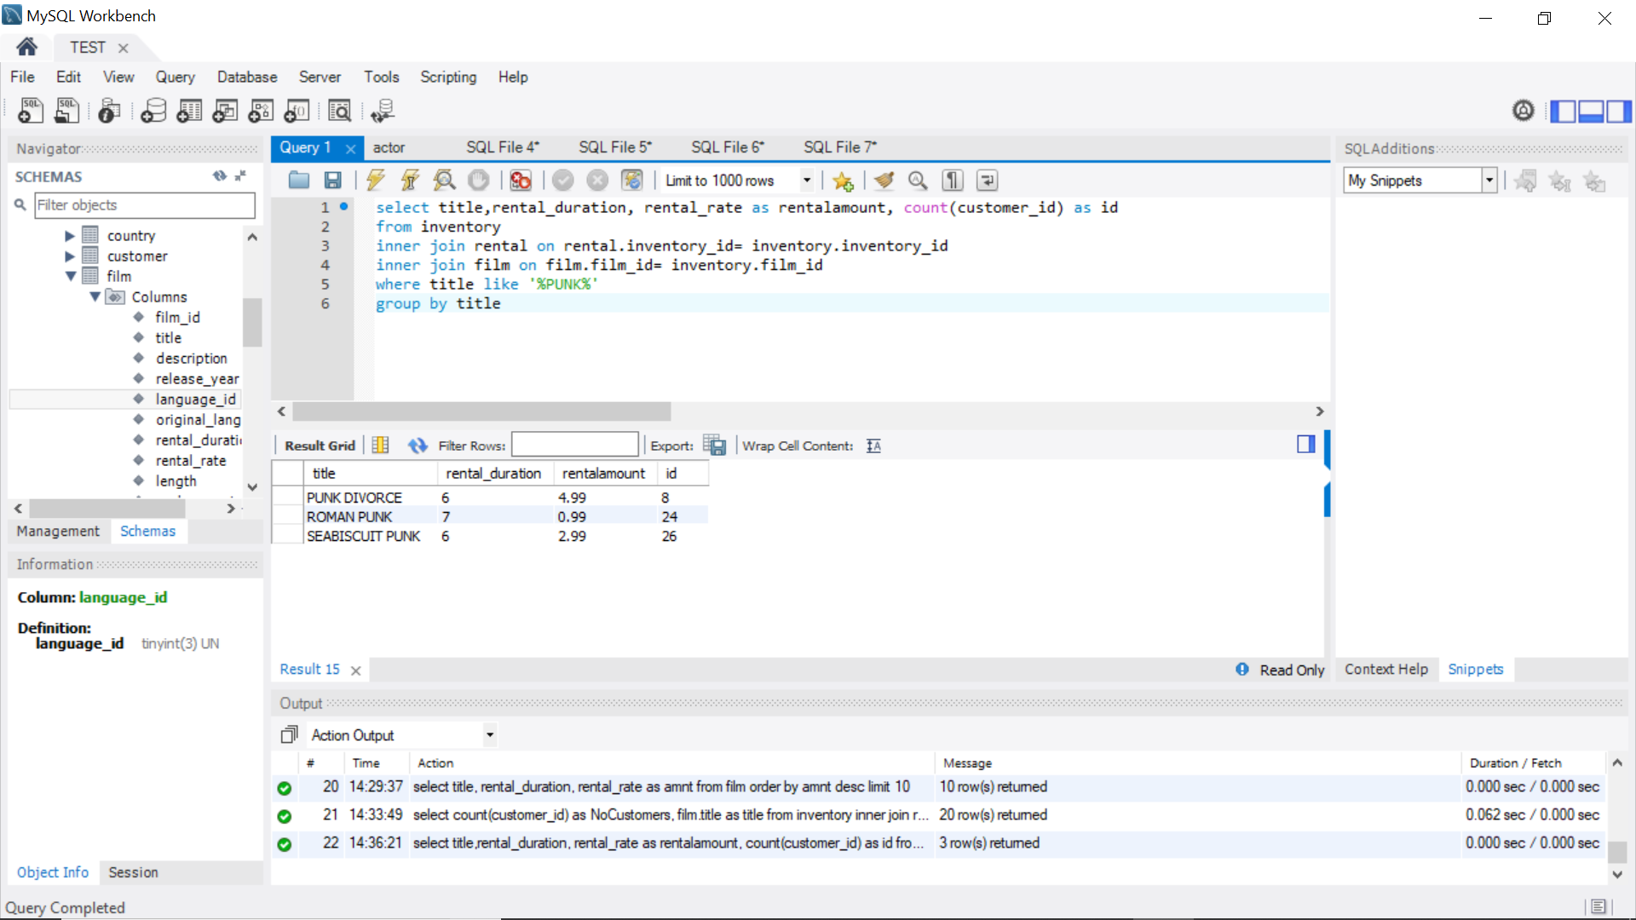

3.5. Contribution by rental amount for films with a documentary category - Treemap (or Heatmap) & sql query

Answer: select title,rental_duration, rental_rate as rentalamount

from film_category

inner join category on category.category_id= film_category.category_id

inner join film on film.film_id= film_category.film_id

where name = 'documentary';

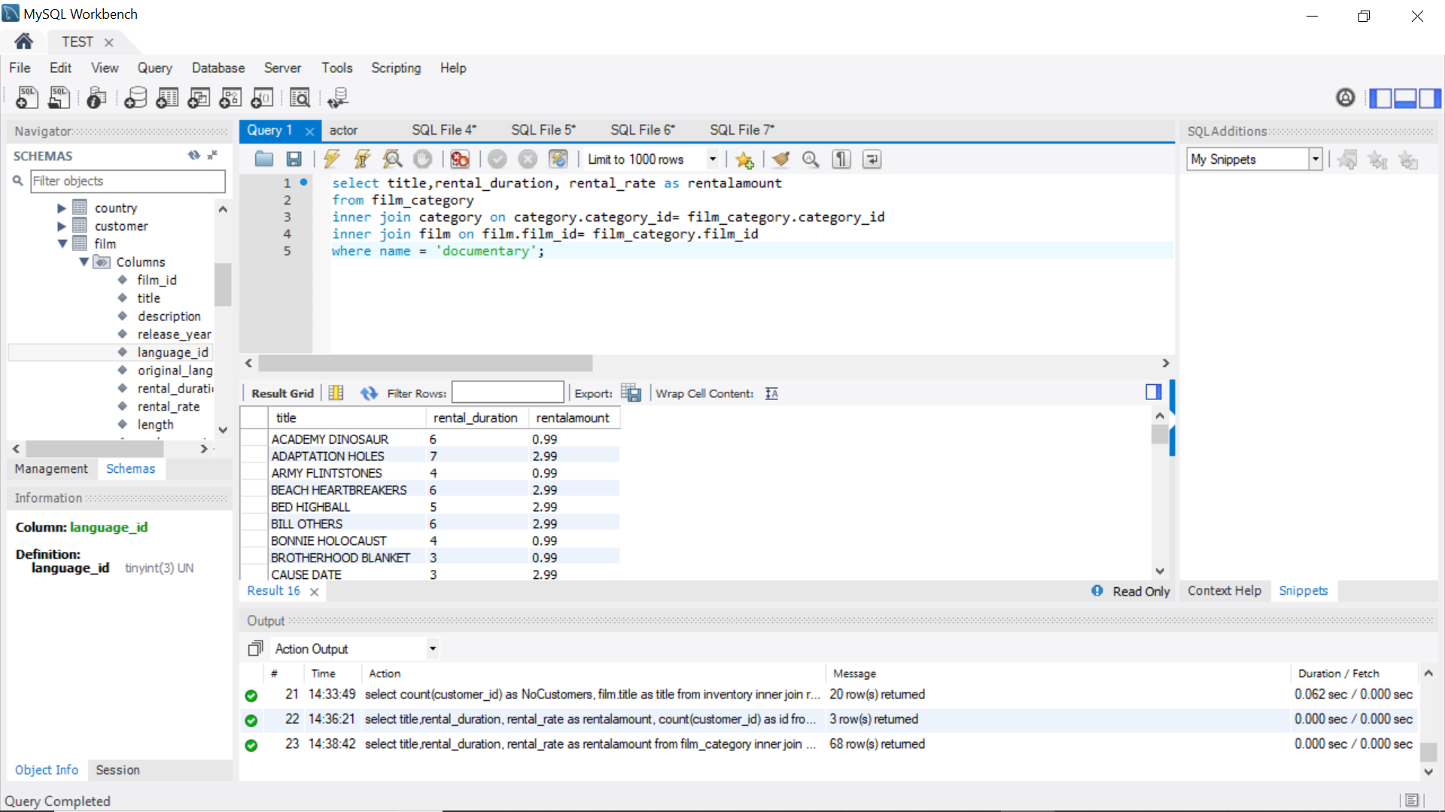

**4.Rentals by Customer (Last name, First Name)**

4.1. List Customers (Last name, First Name) with rental amount, rental quantity, active status, country and city – tabular & sql query

Answer: select Last_name, First_name,Active,country,city,sum(amount) as amnt,

count(Last_name) as quantity

from payment

inner join customer on payment.customer_id= customer.customer_id

inner join customer_list on customer.customer_id= customer_list.ID

group by last_name

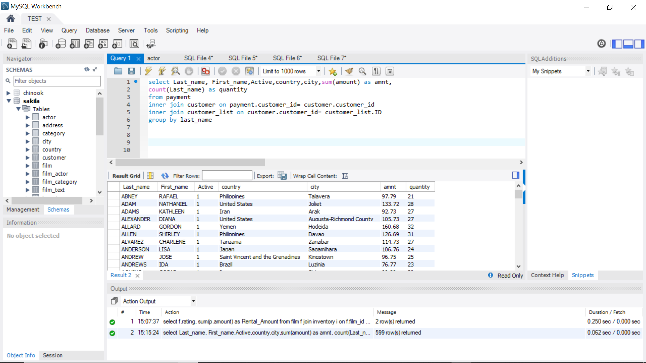

4.2. List top 10 Customers (Last name, First Name) by rental amount (ranked) for PG & PG-13 rated films – bar chart & sql query

Answer: select customer.last_name, customer.first_name, rental_duration,rental_rate as rental, Rating

from customer

inner join rental on customer.customer_id= rental.customer_id

inner join inventory on inventory.inventory_id= rental.rental_id

inner join film on film.film_id= inventory.film_id

where rating='PG' or rating='PG-13'

order by rental desc

limit 10;

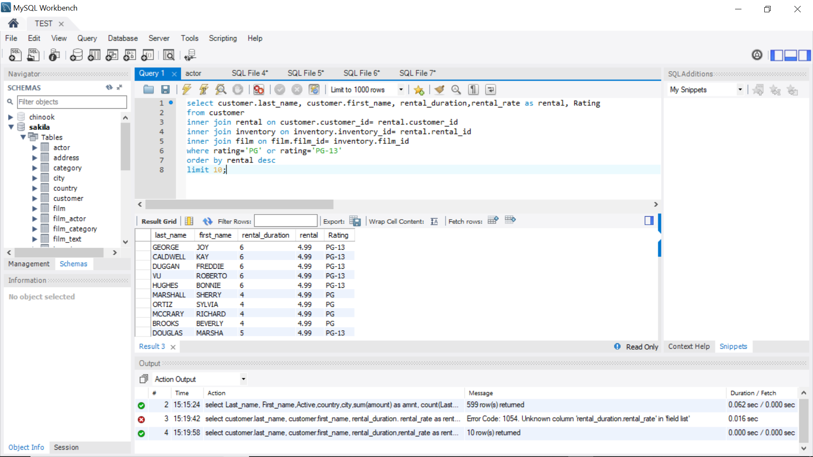

4.3. Contribution by rental amount for customers from France, Italy or Germany - Treemap (or Heatmap) & sql query

Answer: select name, sum(amount) as amnt, Country

from customer_list

inner join payment on customer_list.ID= payment.customer_id

where country= 'France' or country= 'Italy' or country='Germany'

group by country;

